Variable Frequency Drive (VFD)

GA800 Mechanical Specification Submittal
For UL Type 3R Rated Configured Drives (G8C3/G8C6)

GENERAL
The GA800 Configured drive package provides a GA800 in a UL Type 3R enclosure, with space for several commonly used options, such as reactors, circuit breakers, network communication cards, etc. The GA800 Configured drive has been designed for flexibility in providing commonly requested features and options.
The GA800 drive is a high performance PWM (pulse-width-modulated) AC drive. Three-phase input line power is converted to a sine-coded, variable frequency output, which provides optimum speed control of any conventional squirrel cage induction motor. The use of IGBTs (Insulated Gate Bipolar Transistors), with a carrier frequency range of 1 kHz to 15 kHz, permits quiet motor operation.
This drive has one control logic board and keypad for all horsepower ratings. Printed circuit boards employ surface mount technology, providing both high reliability, and small physical size of the printed circuit assemblies.

CONFIGURED PANEL STANDARDS
UL 508A (Industrial Control Panels)
UL, cUL listed
CONFIGURED PANEL SERVICE CONDITIONS
Ambient service temperature: -10°C to 40°C (14°F to 104°F)
Ambient storage temperature: -20°C to 60°C (-4°F to 158°F)
Humidity: 95% RH or less, non-condensing
Altitude: Up to 1000 meters (3300 feet), higher by derating
Service factor: 1.0

QUALITY ASSURANCE
In circuit testing of all printed circuit boards is conducted to ensure proper manufacturing
Final printed circuit board assemblies are functionally tested via computerized test equipment
All fully assembled controls are tested with induction motor loads to assure unit specifications are met

CONSTRUCTION
Input Section- The drive power input stage converts three-phase AC line power into a fixed DC voltage via a solid-state full wave diode rectifier with MOV (Metal Oxide Varistor) surge protection. An internal 3% DC bus reactor at ratings of greater than 40 HP reduces harmonics for cleaner power (optional at smaller ratings).
Intermediate Section- The DC bus maintains a fixed, filtered DC voltage with short circuit protection as a DC supply for the drive output section. The DC bus is monitored by drive diagnostic logic circuits to continuously protect and monitor the power components.
Output Section- Insulated Gate Bipolar Transistors (IGBTs) convert DC bus voltage to a variable frequency, variable voltage PWM sine-coded AC output to the motor. Use of IGBT devices allow motor noise at 60 Hz to measure less than 2 dB (@ 1 meter) above that resulting from across the line operation.
UL Type 3R full enclosure
Available horsepower ratings:
240VAC: 1 thru 150 HP
480VAC: 1 thru 600 HP
Non-volatile memory (EEPROM); all programming memory is saved when the VFD is disconnected from power.
Digital operator keypad and display provide local control and readout capability:
Local/Remote/Start/Stop commands
Speed Reference command
Reset command
Easy to remove heatsink cooling fan with programmable on/off control.
USB mini-B port for quick and easy PC connection

PROTECTION
Output current overload rating of 110% for 60 seconds (normal duty) or 150% for 60 seconds (heavy duty)
Output short circuit protection
Current limited stall prevention (overload trip prevention) during acceleration, deceleration, and run conditions
Optically isolated operator controls
Fault display
“Hunting” prevention logic
Electronic ground fault protection
Electronic motor overload protection (UL approved)
DC bus charge indication
Heatsink overtemperature protection
Cooling fan operating hours recorded
Input/output phase loss protection
Reverse prohibit selectability
Panel SCCR up to 100 kA RMS (dependent on configuration)

OPERATION
Output frequency and speed display can be programmed for other speed-related and control indications, including: Hz, RPM, % of maximum RPM, or custom.
Power loss ride-through (2 seconds capable)
VFD accepts either a direct acting or a reverse acting speed command signal.
Bi-directional “Speed Search” capability to start into a rotating load. Two types: current detection and residual voltage detection
DC injection braking
Remote Run/Stop command input
Two programmable 0 to 10 VDC, -10 to 10 VDC, or 4-20 ma analog outputs, proportional to drive monitor functions including output frequency, output current, output power, PI feedback, output voltage and others
8-Line, 32-character Local/Remote LCD display provides readout functions that include output frequency, output voltage, output current, output power, DC bus voltage, interface terminal status, PI feedback and fault status.
Over 100 programmable functions, resettable to factory presets
User parameter initialization to re-establish project specific parameters
Ramp-to-stop or coast-to-stop selection
Auto restart capability: 0 to 10 attempts with adjustable delay time between attempts
One custom selectable Volts/Hertz pattern and multiple preset Volts/Hertz patterns
Auto speed reference input signal, adjustable for bias and gain
While the VFD is running, operational changes in control and display functions are possible, including:
Acceleration time (0 to 6000 seconds)
Deceleration time (0 to 6000 seconds)
Frequency reference command
Monitor display
Removable digital operator
Automatic energy saving, reduced voltage operation

DRIVE FEATURES

Displacement power factor of .98 throughout the motor speed range
Data logging – record status for up to 10 monitors with adjustable sample time
Built-In real time clock for time and date stamping events along with timer functions for starting, stopping and speed changes without the need for external controls
Voltmeter, ammeter, kilowatt meter, elapsed run time meter, and heatsink temperature monitoring functions
24 VDC, 150 mA transmitter power supply
Input and output terminal status indication
Diagnostic fault indication
VFD efficiency: 96% at half-speed; 98% at full-speed
“S-curve” soft start / soft stop capability
Run/Fault output contacts
Serial communication loss detection and selectable response strategy
“Up/Down” floating point control capability
Output Frequency 0 to 590 Hz
Controlled speed range of 40:1 (V/f, V/f with encoder), 200:1 (open loop vector), 1500:1 (closed loop vector), 200:1 (advanced open loop vector), 20:1 (open loop vector for PM), 100:1 (advanced open loop vector for PM, EZ vector)
Maximum output frequency; 590 Hz
Safe Torque Off: SIL3, PLe
200% starting torque capability, available from 0 Hz to 60 Hz
Remote speed reference (speed command) signal:
0 to 10 VDC (20 kΩ)
4 to 20 mA DC (250 Ω)
Critical frequency rejection capability: three selectable, adjustable bandwidths
Analog/Digital Virtual I/O – internally sends an output to an input (no wiring needed)
Adjustable carrier frequency, from 2 kHz to 15 kHz
Dynamic noise control for quiet motor operation
Programmable security code
Cloud service (Yaskawa Drive Cloud) for product registration and parameter storage
Store up to four additional parameter sets in keypad
Integrated PLC (DriveWorks EZ)
Eight programmable multi-function input terminals (24 VDC) providing 60+ programmable features, including:
Fault reset
Motor operated pot (MOP)
External fault
16 preset speeds
PI control enable / disable
Three programmable multi-function output relays (Form A rated 1 A @ 250 VAC & 30 VDC), providing 50+ functions, including:
Fault status
Run status
Overtorque / undertorque detection
Serial communication status
One fixed “Fault” Form C output relay (Rated 1 A @ 250 VAC & 30 VDC)
Sixteen preset speeds
Built-in Modbus RTU protocols accessible via RS-422/485 communication, which is standard. EtherNet/IP, Modbus TCP/IP, PROFINET, EtherCAT, DeviceNet, and PROFIBUS are optionally available.
Rotational as well as Stationary motor auto-tuning
“Kinetic Energy Braking” (KEB) function stops the motor in up to half the time it would take without this function.
Control Methods Include:
V/f Control
V/f Control with encoder feedback
Open loop vector
Advanced open loop vector
Closed loop vector
Open loop vector for PM
Closed loop vector for PM
Advanced open loop vector for PM
SynRM Motor Control
Motor Types:
Induction
Permanent Magnet
Synchronous Reluctance
Temperature controlled fans
Side by side mounting
LCD keypad with Local/Remote, Start/Stop and Copy keypad functions.
Motor preheat function
Flash upgradeable firmware
Heatsink overtemperature speed fold-back feature
Fan failure detection and selectable drive action
Programming and firmware upgrade without three-phase main power DriveWizard Mobile
Programming Application
LED Status Ring
Conformal coating (IEC 60721-3-3, IP20/Protected Chassis: 3C3, 3S2)

Model Number Configuration (G8C1)

Step 1. Complete the Base Number for the voltage and current rating.

Step 2. Add the Option Code letter for each required option. If an option is not wanted, no character is inserted in that position.
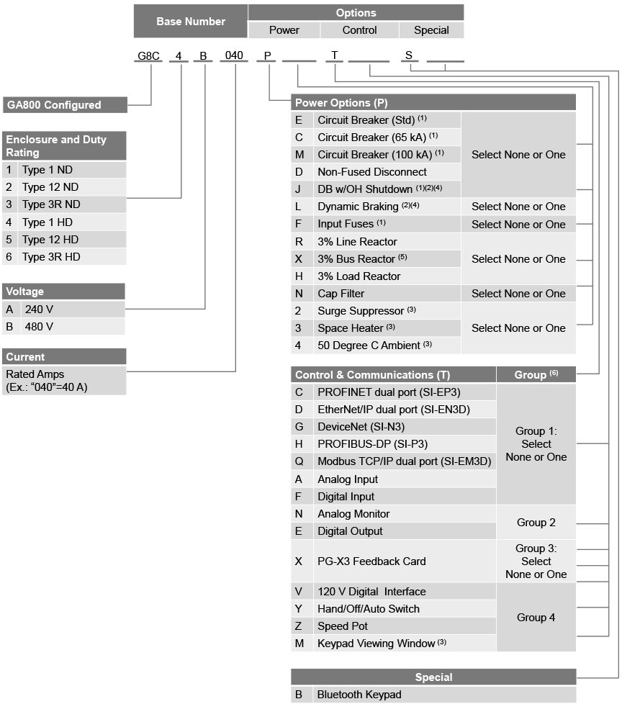
- Option F is not allowed with options E,C,J, or M for the following 480 V package models because input fusing is automatically included:
G8C1B007 - G8C1B720, G8C2B065 - G8C2B720, G8C3B180 - G8C3B720
G8C4B004 - G8C4B590, G8C5B052 - G8C5B590, G8C6B156 - G8C6B590
- Options J and L not allowed together.
- Type 3R enclosures only.
- Not available for Type 3R enclosures.
- 3% Bus reactors are only available as an option on small ratings - see table; large drives have a bus reactor as standard.
- If no option from Group 1 or Group 3 is selected, then both options from Group 2 may be selected.
If no option from Group 1 is selected, then ALL options from Group 2 and Group 3 may be selected.
Select anything from Group 4, regardless of other group selections.

ENCLOSURE TYPE
(1) The Normal Duty drive and Configured controls are provided in a Type 1 enclosure, large enough to accommodate any or all of the Configured package options.
(4) The Heavy Duty drive and Configured controls are provided in a Type 1 enclosure, large enough to accommodate any or all of the Configured package options.
(2) The Normal Duty drive and Configured controls are provided in a Type 12 enclosure, large enough to accommodate any or all of the Configured package options.
(5) The Heavy Duty drive and Configured controls are provided in a Type 12 enclosure, large enough to accommodate any or all of the Configured package options.
(3) The Normal Duty drive and Configured controls are provided in a Type 3R enclosure, large enough to accommodate any or all of the Configured package options.
(6) The Heavy Duty drive and Configured controls are provided in a Type 3R enclosure, large enough to accommodate any or all of the Configured package options.

VOLTAGE
(A) 240 volt model for nominal, 230 or 240 VAC (+10/-15%); 60 or 50 Hz (+/-5%) systems
(B) 480 volt model for nominal, 380, 400, 415, 440, 460 or 480 VAC (+10/-15 %); 60 or 50 Hz (+/-5%) systems

[P] POWER OPTIONS
(E) This option provides a circuit breaker with operating handle.
(C) This option provides a circuit breaker with operating handle and an Interrupting Capacity of 65 kA.
(M) This option provides a circuit breaker with operating handle and an Interrupting Capacity of 100 kA.
(D) This option provides a non-fused disconnect with operating handle.
(F) This option provides input fuses for drive short circuit protection.
(R) No form of input impedance is normally required for the GA800 Configured. A 3% line reactor is available if additional impedance is desired, usually to reduce the effects of line-side transients and input current THD.
(X) Large HP drives include 3% bus impedance. A 3% bus reactor is available for small HP drives (see table) if additional impedance is desired, usually to reduce the effects of line-side transients and input current THD.
(H) No form of output impedance is normally required for the GA800 Configured. A 3% load reactor is available if additional output impedance is desired, usually for long lead-lengths or noise reduction.
(N) The standard configuration does not include a filter. The cap filter is a delta-wye capacitive network, used to help attenuate electrical noise.
(L) This option provides 10-15% duty cycle braking capability (DB resistors not included) to improve deceleration performance. This option does not include over temperature protection. Not available for Type 3R enclosures.
(J) This option provides 10-15% duty cycle braking capability (DB resistors not included) to improve deceleration performance. A shunt trip circuit breaker (equivalent to option E) and circuitry is also provided to disconnect the input power from the drive if the DB overtemperature switches activate. Not available for Type 3R enclosures.

[P] POWER OPTIONS (con’t)
(2) This option will offer some degree of protection from transient surges coming through the power line cables. Lightning strikes are the most common source of surges. This option is only available for the Type 3R enclosure.
(3) This option maintains the internal cabinet temperature to reduce condensation. This option is only available for the Type 3R enclosure.
(4) This option will allow the enclosure to be operated in an ambient temperature of 50 °C (122 °F). The standard basic design is rated for 40 °C ambient. This option is only available for the Type 3R enclosure.

[T] CONTROL & COMMUNICATION OPTIONS
(D) This option allows the drive to communicate on an Ethernet/IP network.
(G) This option allows the drive to communicate on a DeviceNet network.
(H) This option allows the drive to communicate on a PROFIBUS network.
(C) This option allows the drive to communicate on a PROFINET network.
(Q) This option allows the drive to communicate on a Modbus TCP/IP network.
(A) This option provides 3 additional high-resolution analog inputs (13 Bit to the drive.
(F) This option provides 16 additional digital inputs (binary or BCD; 8, 12, to the drive.
(N) This option provides 2 additional isolated signal outputs (11 Bit + Sign) remote monitoring of any two of the drive’s “U1” parameters.
(E) This option provides 8 additional digital outputs for use in monitoring the of the drive.
(X) This option provides speed feedback using a line driver pulse generator
(V) This option converts external 120 VAC control signals to the drive’s 24 digital input terminals (S1 through S8).
(Y) This option provides a door-mounted Hand/Off/Auto Selector Switch determining start/stop and speed control.
(Z) This option provides a door-mounted Speed Pot with knob to control speed.
(M) All GA800 standard drive packages include a door mounted keypad enclosed in a plastic bezel with a clear door that opens for access. Option M (for Type only) provides a larger painted steel solution, including a keylock that protects keypad and other door mounted controls.

[S] Special

(B) This option equips the configured package with a BlueTooth enabled keypad.

