Variable Frequency Drive (VFD)

HV600 Redundant Package Specification Submittal

GENERAL
The HV600 drive is a high performance PWM (pulse-width-modulated) The Redundant drive package that contains two (2) equally sized HV600 drives. Three-phase input line power is converted to a sinusoidal, variable frequency output, which provides optimum speed control of any conventional squirrel cage induction motor. The use of IGBTs (Insulated Gate Bipolar Transistors), with a carrier frequency range of 1 kHz to 12.5 kHz, permits quiet motor operation.
This drive has one control logic board for all horsepower ratings. Printed circuit boards employ surface mount technology, providing both high reliability, and small physical size of the printed circuit assemblies. The microprocessor delivers the computing power necessary for complete three phase motor control in building automation systems.
Operating Principle: Input three-phase AC line voltage is first rectified to a fixed DC voltage. Using pulse width modulation (PWM) inverter technology, the DC voltage is processed, to produce an output waveform in a series of variable-width pulses. Unique firmware algorithms optimize motor magnetization through control of voltage, current and frequency applied to generate a nearly sinusoidal output waveform.

STANDARDS
UL 508A (Industrial Control Panels)
BTL Listed
UL, cUL listed

ENVIRONMENTAL & SERVICE CONDITIONS
Ambient service temperature:
-10°C to 40°C (14°F to 104°F)
Ambient storage temperature:
-20°C to 70°C (-4°F to 158°F)
Humidity: 0 % to 95 %, non-condensing
Altitude: to 1000 meters (3300 feet), higher by derating
Service factor: 1.0
Vibration: 9.81m/s² (1 G) maximum at 10 to 20 Hz, 2.0 m/s² (0.2 G) at 20 Hz to 55 Hz.
RoHS Compliant

QUALITY ASSURANCE
In circuit testing of all printed circuit boards is conducted, to ensure proper manufacturing.
Final printed circuit board assemblies are functionally tested, via computerized test equipment.
All fully assembled controls are computer tested with induction motor loads to assure unit specifications are met.
The average MTBF (Mean Time Between Failure) is 28 years

CONSTRUCTION
Input Section of the VFD - VFD power input stage converts three phase AC line power into a fixed DC voltage, via a solid state full wave diode rectifier, with MOV (Metal Oxide Varistor) surge protection. An internal 5% DC bus reactor reduces harmonics for cleaner power.
Intermediate Section of the VFD - DC bus maintains a fixed DC voltage, with filtering and short circuit protection, as a DC supply to the VFD output section. It is interfaced with the VFD diagnostic logic circuit, to continuously monitor and protect the power components.
Output Section of the VFD - Insulated Gate Bipolar Transistors (IGBTs) convert DC bus voltage to a variable frequency and voltage, utilizing a PWM sine-coded output to the motor. IGBT output allows motor noise, at 60 Hz, to measure less than 2 dB
(@ 1 meter) above that resulting from across the line operation.

CONSTRUCTION (continued)
Power and control electronics housings:
UL Type 1 or UL Type 12 wall-mounted enclosure:
480 V, 1 thru 100 HP
UL Type 1 or UL Type 12 floor-mounted enclosure:
480 V, 125 thru 250 HP
Microprocessor based control circuit
Simple PC Connection
Non-Volatile memory (EEPROM); all programming memory is saved when the VFD is disconnected from power.
Digital operator keypad and display provides local control and readout capability:
Hand/Off/Auto commands
Speed Reference command
Reset command
Easy to remove heat sink cooling fan with programmable on/off control

PROTECTION
Output current overload rating of 110% for 60 seconds, 140% for 2 seconds, 175% instantaneous
Output short circuit protection
Current limited stall prevention (overload trip prevention) during acceleration, deceleration, and run conditions
Optically isolated operator controls
Fault display
“Hunting” prevention logic
Electronic ground fault protection
Electronic motor overload relay protects the motor while operating.
Motor current is displayed on each of the drives keypad
Proof of flow or loss of flow detection can be displayed on both drives
DC bus charge indication
Heat sink over temperature protection
Cooling fan operating hours recorded
Input/Output phase loss protection
Line voltage sensors to monitor for brownout and blackout conditions with adjustable fault levels to ensure the proper settings pursuant to each application.
Reverse can be enabled or disabled
Short circuit withstand rating of 100KAIC RMS with customer provided branch circuit protection.
Two smoke purge/fireman’s override modes (Across the line or speed selectable via the drive)

OPERATION
Output frequency and speed display can be programmed for other speed-related and control indications, including: RPM, CFM, GPM, PSI, in WC, % of maximum RPM or custom
Power loss ride-thru (2 seconds capable)
Time delay on start, peak avoidance
VFD accepts either a direct acting or a reverse acting speed command signal
Bi-directional “Speed Search” capability, in order to start into a rotating load. Two types: current detection and residual voltage detection
DC injection braking, to prevent fan “wind milling”
Remote Run/Stop command input
Two programmable 0 to 10 VDC or 4-20ma analog outputs, proportional to drive monitor functions including: output frequency, output current, output power, PI feedback, output voltage and more.
Eight Programmable HVAC specific application macros
Over 100 programmable functions, resettable to factory HVAC presets
User parameter initialization, re-establish project specific parameters
Ramp-to-stop or coast-to-stop selection
Auto restart capability: 0 to 10 attempts with adjustable delay time between attempts
One custom selectable Volts/Hertz pattern and multiple preset Volts/Hertz patterns
Auto speed reference input signal, adjustable for bias and gain
While the VFD is running, operational changes in control and display functions are possible, including:
Acceleration time (0 to 6000 seconds)
Deceleration time (0 to 6000 seconds)
Frequency reference command
Hand/Off/Auto commands
Monitor display
Removable digital operator
Automatic energy saving, reduced voltage operation

PRODUCT FEATURES
Displacement power factor of .98 throughout the motor speed range
Internal EMI/RFI filter complies with IEC 61800-3 restricted distribution for first environment
Built-In real time clock for time and date stamping events along with timer functions for starting, stopping and speed changes without the need for external controls
Volt meter, ammeter, kilowatt meter elapsed run time meter and heat sink temperature monitoring functions
Two internal (PI) Controls
- Drive internal PI closed loop control with selectable engineering units
- Independent PI control for use with external device
Differential PI feedback feature
Sleep function in both closed loop and open loop control
Feedback signal low pass filter
Feedback signal loss detection and selectable response strategy
Feedback signal inverse and square root capability
24 Vdc, 150ma transmitter power supply
Input and output terminal status indication
Diagnostic fault indication
VFD efficiency: 96% at half-speed; 98% at full-speed
“S-curve” soft start / soft stop capability
Run/Fault output contacts
Serial communication loss detection and selectable response strategy
“Up/Down” floating point control capability
Controlled speed range of 40:1
Critical frequency rejection capability: 3 selectable, adjustable bandwidths
100% starting torque capability, available from 3 Hz to 60 Hz
Remote speed reference (speed command) signal:
0 to 10 VDC (20 kΩ)
4 to 20 mA DC (250 Ω)
Adjustable carrier frequency, from 1 kHz to 12.5 kHz
Dynamic noise control for quiet motor operation
Programmable security code
Eight Programmable digital inputs (24Vdc, 8mA) shall be provided for Remote Transfer from drive to drive, Safety Interlock, BAS Interlock.
Four Programmable form C relays (24Vdc/120 VAC, 2 Amp) for: “Motor Run”, “Damper Actuator”, “Auto Transfer”, “Drive Run”, “Hand Mode”, “Auto Mode”, “System Fault”,”Serial Com Run” and numerous other options.
Seven preset speeds
Stationary motor auto-tuning
“Kinetic Energy Braking” (KEB) function stops the motor in up to half the time it would take without this function.
LCD keypad with Hand/Off/Auto functions.
Motor preheat function
Flash upgradeable firmware
Heat sink over temperature speed fold-back feature
“Bumpless” transfer between Hand and Auto modes
Emergency override can be used as “smoke purge” function
Fan failure detection and selectable drive action
Input disconnect switch with a lockable, through-the-door operating mechanism
Redundant drive package are factory assembled, and electrically interlocked, utilizing fuses for drive isolation.
VFD’s can be serviced or removed, with other drive left in place.
UL Type 1 or UL Type 12 enclosure
Input disconnect with a lockable, through-the-door operating mechanism
2 Output contactors
120 VAC fused control power transformer
Control and safety circuit terminal strip
22 mm LED pilot lights; “Drive Fault A”, “Drive Fault B”, “External Fault”, “Drive Run A” and “Drive Run B”
“Fault XFR Man/Auto” selector switch
“Hand/Off/Auto” selector switch
“Auto DRV A / DRV B” selector switch
“Drive A Fault”, “Drive B Fault” and “External Fault” annunciation contacts
Switch selectable auto transfer to alt drive on drive fault
Switch selectable remote transfer to alt drive via contact closure
Switch selectable smoke purge function
100 VA of 120-volt power available for customer use at terminal strip
Includes Two HV600 drives in single enclosure
Semiconductor fuses for each drive
Single input/output wiring points
Single control wiring point
Two door mounted keypads
Selectable Manual or Auto Transfer
Test A / Normal / Test B switch
Integral damper control circuit
BACnet, Siemens Apogee, Metasys N2, and Modbus communication protocols as standard with the ability to configure controller parameters, view controller monitors, control I/O, clear faults and view controller status.

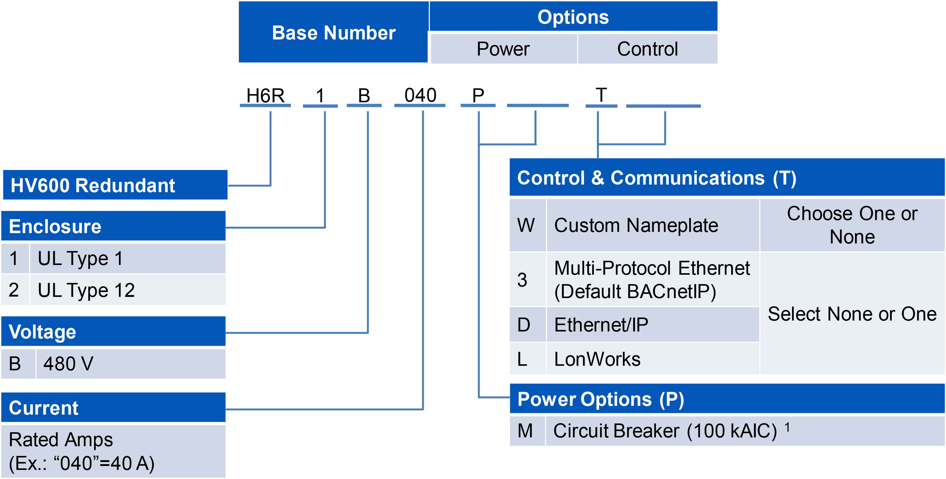

ENCLOSURE TYPE
[1] UL Type 1 Enclosure
[2] UL Type 1 Enclosure

VOLTAGE
[B] 480 volt model for nominal, 380, 400, 415, 440, 460 or 480 VAC (+10/-15 %); 60 or 50 Hz (+/-5%) systems

[P] POWER OPTIONS
[M] Circuit Breaker Option is a 100 kAIC rated circuit breaker with fuses. When option (M) is specified, the configured drive package will be rated at 100 kAIC.
(Replaces default input disconnect)

[T] CONTROL & COMMUNICATION OPTIONS
[W] Engraved nameplate

[3] Multi-Protocol Ethernet (Default BACnetIP)
[D] Ethernet/IP
[L] LonWorks

