Variable Frequency Drive (VFD)

HV600 Mechanical Specification Submittal

For Enclosed Configured UL Type 3R Rated (H6C3) Packages

GENERAL
The HV600 is a high performance PWM (pulse-width-modulated) AC drive. Three-phase input line power is converted to a sine-coded, variable frequency output, which provides optimum speed control of any conventional squirrel cage induction motor. The use of IGBTs (Insulated Gate Bipolar Transistors), with a carrier frequency range of 2 kHz to 12.5 kHz, permits quiet motor operation.
This drive has one control logic board for all horsepower ratings. Printed circuit boards employ surface-mount technology, providing both high reliability, and small physical size of the printed circuit assemblies. The microprocessor delivers the computing power necessary for complete three-phase motor control in building automation systems.
Operating Principle: Input three-phase AC line voltage is first rectified to a fixed DC voltage. Using pulse width modulation (PWM) inverter technology, the DC voltage is processed to produce an output waveform in a series of variable-width pulses. Unique firmware algorithms optimize motor magnetization through control of voltage, current, and frequency applied to generate a nearly sinusoidal output waveform.

STANDARDS
UL 508A (Industrial Control Panels)
BTL Listed
UL, cUL listed
CBC, IBC, ASCE7, ICC-ES 156
HCAI (OSHPD)

ENVIRONMENTAL & SERVICE CONDITIONS
Ambient service temperature: Enclosed Configured UL Type 3R: -10°C to 40°C
Ambient storage temperature: Enclosed Configured UL Type 3R: -20°C to 70°C
Humidity: 0% to 95%, non-condensing
Altitude: to 1,000 meters (3,300 feet); higher by derating
Service factor: 1.0
RoHS 2 Compliant

QUALITY ASSURANCE
In-circuit testing of all printed circuit boards is conducted to ensure proper manufacturing.
Final printed circuit board assemblies are functionally tested via computerized test equipment.
All fully assembled controls are computer tested with induction motor loads to assure unit specifications are met.
The average MTBF (Mean Time Between Failure) is 28 years.

CONSTRUCTION
VFD power input stage converts three-phase AC line power into a fixed DC voltage via a solid-state full-wave diode rectifier with MOV (Metal Oxide Varistor) surge protection. An internal 5% split choke built in both positive and negative DC bus reduces harmonics for cleaner power.
Intermediate Section of the VFD - DC bus maintains a fixed DC voltage with filtering and short circuit protection as a DC supply to the VFD output section. It is interfaced with the VFD diagnostic logic circuit to continuously monitor and protect the power components.
Output Section of the VFD - Insulated Gate Bipolar Transistors (IGBTs) convert DC bus voltage to a variable frequency and voltage, utilizing a PWM sine-coded output to the motor. Motor noise at 60 Hz is less than 2 dB above the motor noise from across-the-line operation when measured at a distance of one meter.

POWER AND CONTROL ELECTRONIC HOUSINGS
UL Type 3R full enclosure: 208 V, 0.5 thru 100 HP; 240 V, 0.5 thru 100 HP; 480 V, 0.5 thru 250 HP
Microprocessor-based control circuit
Non-volatile memory (EEPROM); all programming memory is saved when the VFD is disconnected from power.
Digital operator keypad and display provide local control and readout capability:
Hand/Off/Auto commands
Speed Reference command
Reset command
Easy to remove heat sink cooling fan with programmable on/off control
USB mini-B port for quick and easy PC connection

PROTECTION
Output current overload rating of 110% for 60 seconds, 140% for 2 seconds, 175% instantaneous
Output short circuit protection
Current limited stall prevention (overload trip prevention) during acceleration, deceleration, and run conditions
Optically isolated operator controls
Fault display
“Hunting” prevention logic
Electronic ground fault protection
Electronic motor overload relay protects the motor while in operation
Motor current display as well as verification that the motor is running
Proof of flow/loss of flow detection
DC bus charge indication
Heatsink overtemperature protection
Cooling fan operating hours recorded
Input/output phase loss protection
Line voltage sensors to monitor for brownout and blackout conditions with adjustable fault levels to ensure the proper settings pursuant to each application.
Reverse prohibit selectability
Short circuit withstand rating of 100 KA RMS with customer provided branch circuit protection.
Two emergency override modes (across-the-line or speed selectable via the drive)

OPERATION
Output frequency and speed display can be programmed for other speed-related and control indications, including: RPM, CFM, GPM, PSI, in WC, % of maximum RPM, or custom.
Power loss ride-through (2 seconds capable)
Time delay on start; peak avoidance for smooth generator switchover
VFD accepts either a direct acting or a reverse acting speed command signal.
Bi-directional “Speed Search” capability to start into a rotating load. Two types: current detection and residual voltage detection
DC injection braking, to prevent fan “windmilling”
Remote Run/Stop command input
Eight programmable HVAC specific application presets
Over 100 programmable functions, resettable to factory HVAC presets
User parameter initialization to re-establish project specific parameters
Ramp-to-stop or coast-to-stop selection
Auto restart capability: 0 to 10 attempts with adjustable delay time between attempts
One custom selectable Volts/Hertz pattern and multiple preset Volts/Hertz patterns
Auto speed reference input signal, adjustable for bias and gain
While the VFD is running, operational changes in control and display functions are possible, including:
Acceleration time (0 to 6000 seconds)
Deceleration time (0 to 6000 seconds)
Frequency reference command
Hand/Off/Auto commands
Monitor display
Removable digital operator
Automatic energy saving, reduced voltage operation

PRODUCT FEATURES
Displacement power factor of .98 throughout the motor speed range
Internal EMI/RFI filter complies with EN 61800-3
Built-In real time clock for time and date stamping events along with timer functions for starting, stopping and speed changes without the need for external controls
Voltmeter, ammeter, kilowatt meter, elapsed run time meter, and heatsink temperature monitoring functions
Two internal (PI) controls
Drive internal PI closed-loop control with selectable engineering units
Independent PI control for use with external device
Sleep function in both closed loop and open loop control
Feedback signal low pass filter
Feedback signal loss detection and selectable response strategy
Feedback signal inverse and square root capability
24 VDC, 150 mA transmitter power supply
Seven programmable multi-function input terminals (24 VDC) providing 60+ programmable features, including:
Customer Safeties
BAS / Damper Interlock
Emergency Override – BAS interlock mode
min/max speed setting
16 preset speeds
PI control enable / disable
One Dedicated Fault Form C relay (30 VDC/250 VAC, 2 Amp), and 3 programmable Form A relays for: “Motor Run,” “Damper Actuator,” “Auto Transfer,” “Drive Run,” “Hand Mode,” “Auto Mode,” “System Fault,” ”Serial Com Run,” and numerous other options.
Two programmable 0 to 10 VDC or 4-20 ma analog outputs, proportional to drive monitor functions including output frequency, output current, output power, PI feedback, output voltage and others
Remote speed reference (speed command) signal:
0 to 10 VDC (20 kΩ)
4 to 20 mA DC (250 Ω)
Nine preset speeds
Input and output terminal status indication
Diagnostic fault indication
VFD efficiency: 96% at half-speed; 98% at full-speed
“S-curve” soft start / soft stop capability
Run/Fault output contacts
Serial communication loss detection and selectable response strategy
“Up/Down” floating point control capability
Output Frequency 0 to 400 Hz
Controlled speed range of 40:1
Critical frequency rejection capability: three selectable, adjustable bandwidths
140% starting torque capability, available from 3 Hz to 60 Hz
Adjustable carrier frequency, from 2 kHz to 12.5 kHz
Analog/Digital Virtual I/O – internally sends an output to an input (no wiring needed)
Dynamic noise control for quiet motor operation
Programmable security code
Cloud service (Yaskawa Drive Cloud) for product registration and parameter storage
Store up to four additional parameter sets in keypad
Integrated PLC (DriveWorks EZ)
Rotational as well as Stationary motor auto-tuning
“Kinetic Energy Braking” (KEB) function stops the motor in up to half the time it would take without this function.
Control Methods Include:
V/F Control
Enhanced PM Motor control
SynRM Motor Control
Motor Types:
Induction
Permanent Magnet
Synchronous Reluctance
Temperature controlled fans
LCD keypad with Hand/Off/Auto and Copy keypad functions.
Motor preheat function
Self-regulating lead/lag control for multiple drives (up to 4)
Drive/motor alternation control (share motor run time for lead drive/motor)
Up to four PID setpoints
Draw down level selection for PID setpoint
Anti-no-flow control for deadhead protection
Pre-charge pump functionality
Low city alarm digital input
State/de-state control – add/remove drive based on feedback or output frequency
Single phase foldback
Flash upgradeable firmware
Heatsink overtemperature speed fold-back feature
“Bumpless” transfer between Hand and Auto modes
Emergency override can be used as “smoke purge” function
Fan failure detection and selectable drive action
Programming and firmware upgrade without three-phase main power DriveWizard Mobile
Programming Application
LED Status Ring
Conformal coating (IEC 60721-3-3, 3C2, 3S2)
Complete package is factory assembled.
Input disconnect switch with a lockable, through-the-door operating mechanism
BACnet, Siemens APOGEE FLN, Metasys N2, and Modbus RTU communication protocols as standard, with the ability to configure controller parameters, view controller monitors, control I/O, clear faults, and view controller status. EtherNet/IP, Modbus TCP/IP and LonWorks are optionally available.
BACnet Health monitors including Net Health, Tokens Received/Transmitted, Messages Received/Transmitted, Next/Previous Node Address, Max/Min Master Found, number of Nodes on Network, COV, MSTP Loop Time, CRC Errors, MSTP Tokens Lost/Retry, Deadtime Average.
Door mounted control keypad with HOA LCD display for “Control Power,” “Drive Ready,” “Drive Run,” “Drive Selected,” “Drive Fault,” “Drive Test,” “Motor OL”, ”Safety Open” “BAS Interlock,” “Auto Run”, “Emergency Override,” “Hand Mode,” “Off Mode”, and “Auto Mode.”
Damper control circuit with end-of-travel feedback capability including two adjustable wait time functions. One is a run delay time, where the drive will operate at a preset speed before the damper opens to pressurize the system. The other time function is an interlock wait time, so if the damper has not fully opened within the specified time, a fault will be declared.
Selectable energy savings and harmonic reduction mode.

Model Number Configuration (H6C3)

Step 1. Complete the Base Number for the voltage and current rating.

Step 2. Add the Option Code letter for each required option. If an option is not wanted, no character is inserted in that position.

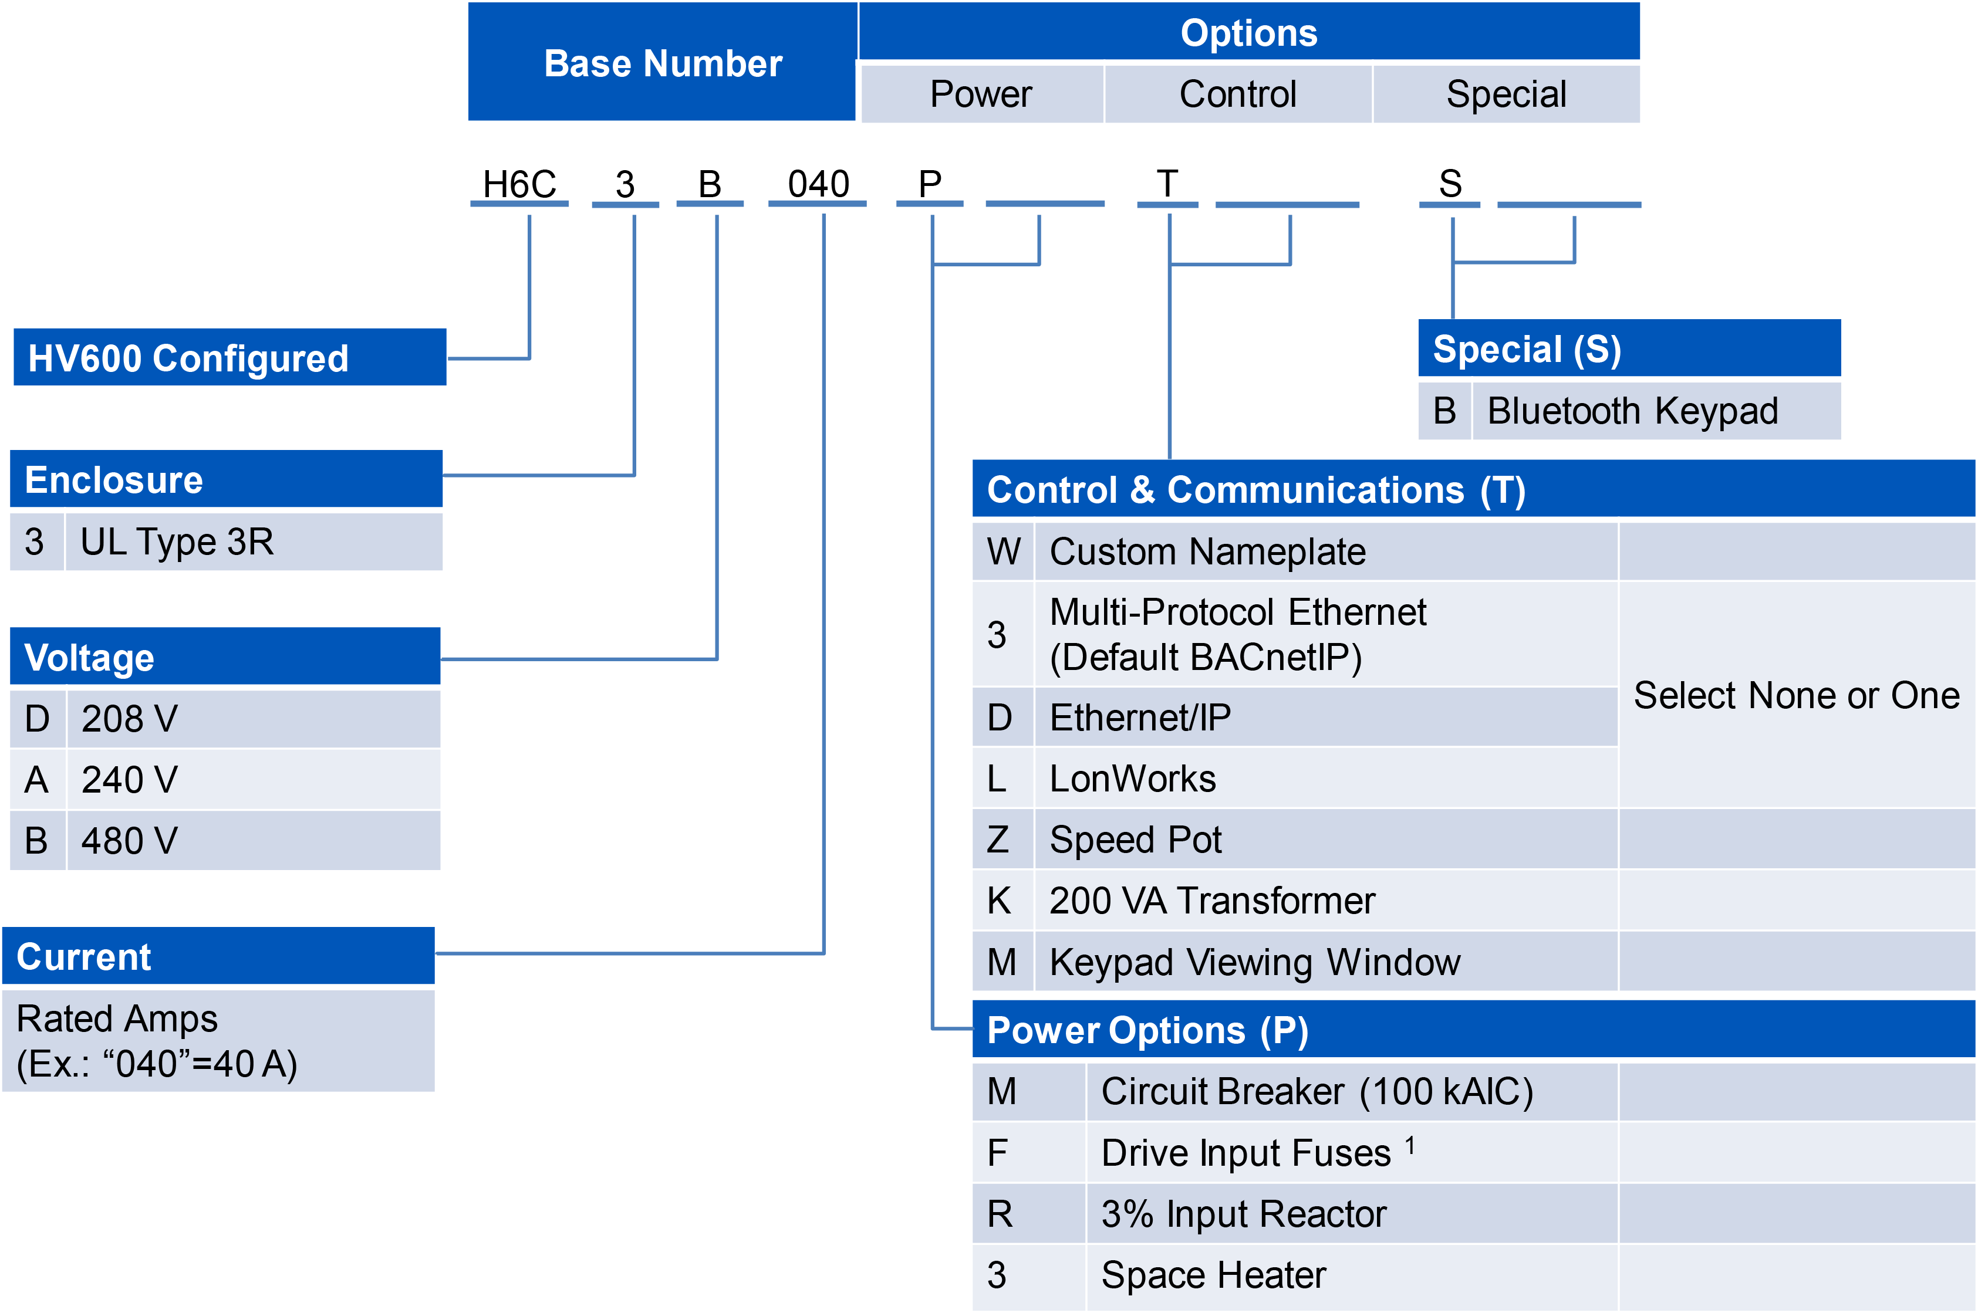

ENCLOSURE TYPE
[3] UL Type 3R Enclosure

VOLTAGE
[D] 208 volt model for nominal, 200 or 208 VAC (+10/-15%); 60 or 50 Hz (+/-5%) systems
[A] 240 volt model for nominal, 230 or 240 VAC (+10/-15%); 60 or 50 Hz (+/-5%) systems
[B] 480 volt model for nominal, 380, 400, 415, 440, 460 or 480 VAC (+10/-15 %); 60 or 50 Hz (+/-5%) systems

[P] POWER OPTIONS
MAIN INPUT DISCONNECT (Default)
Input disconnect switch with a lockable, through-the-door operating mechanism, no branch short circuit protection.
[M] Circuit Breaker Option is a 100 kAIC rated circuit breaker with fuses. When option (M) is specified, the configured drive package will be rated at 100 kAIC.
(Replaces default input disconnect)
[P] POWER OPTIONS (Continued)
[F] Drive Input fusing is available as a selection when the Circuit Breaker option is not already being used. Use this selection when drive input fusing is desired with the default input disconnect switch.
[R] 3% AC Input Line Reactor
[3] Space Heater

[T] CONTROL & COMMUNICATION OPTIONS
[W] Engraved nameplate
[Z] Speed Pot
[K] 200 VA Transformer
[M] Keypad Viewing Window
One or None:
[3] Multi-Protocol Ethernet (Default BACnetIP)
[D] Ethernet/IP
[L] LonWorks

[S] Special
[B] Bluetooth Keypad

